**Practical No 10**

1. Drag and drop a DropDownList in a web form. Bind DropDownList

* With data Using smart tag
* with XML data
* with SQL Server data

Show the output for each

**Bind DropDownList with smart tag**

Click on the smart tag and click on edit items as seen here

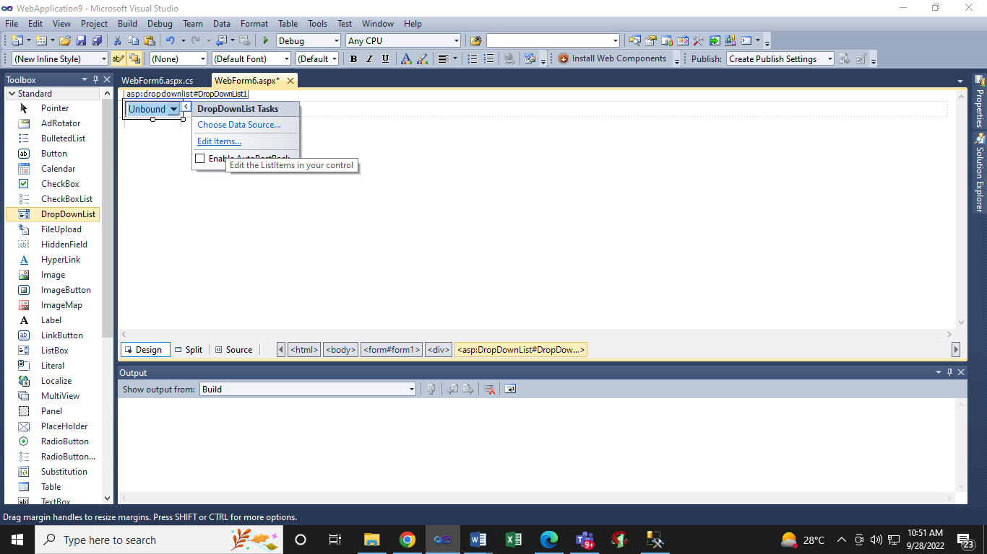

The below window opens

Here click on Add and Lisitem is see

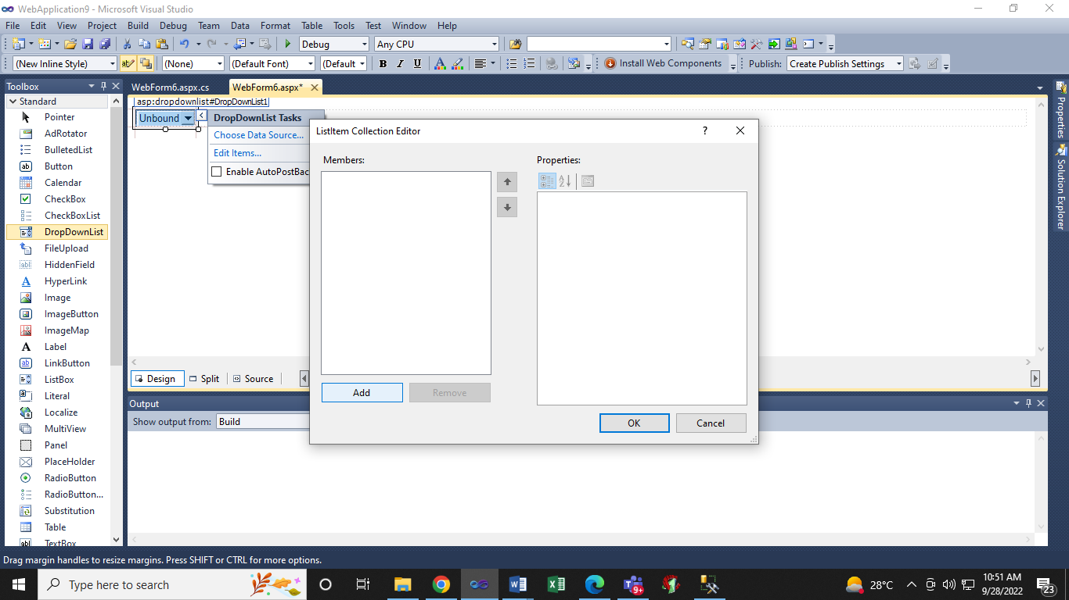

Here click on Add in the above window and Lisitem is seen as below

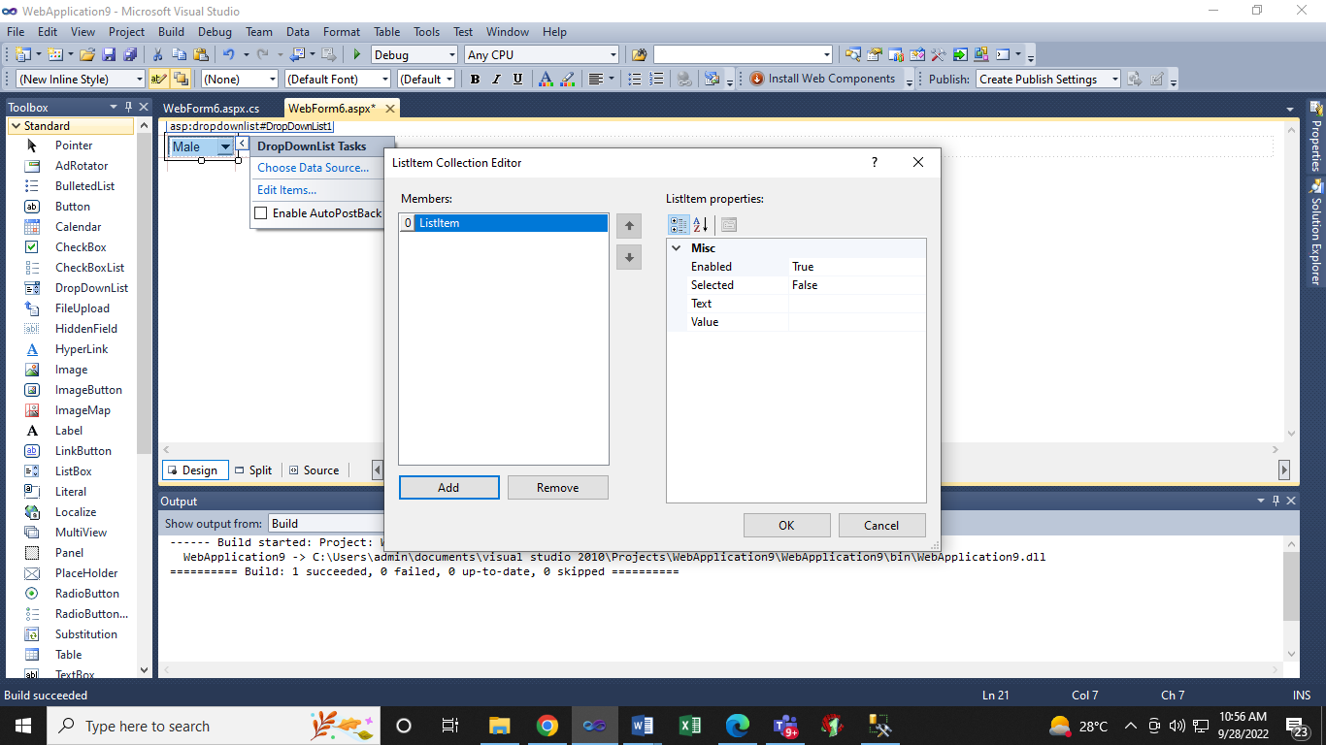

Enter the data in Text and the same is added in Value too as seen below. Add the items necessary and click OK and Run to see the Output.

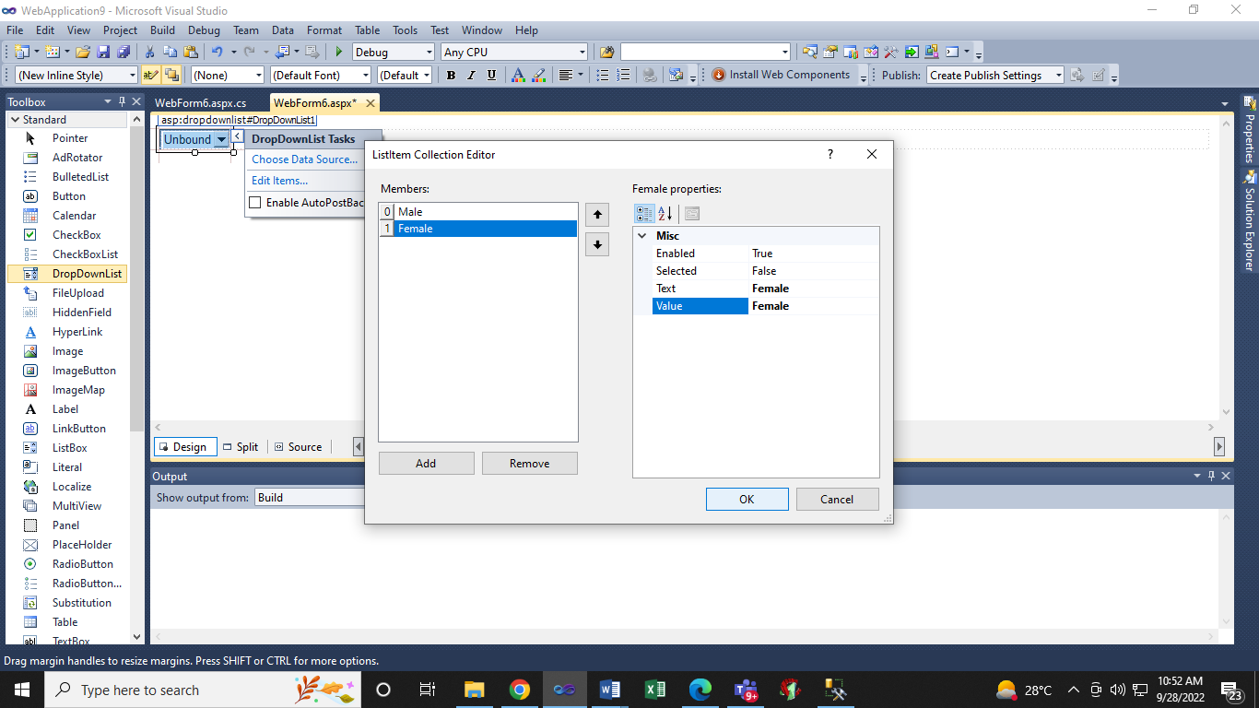

**Output**

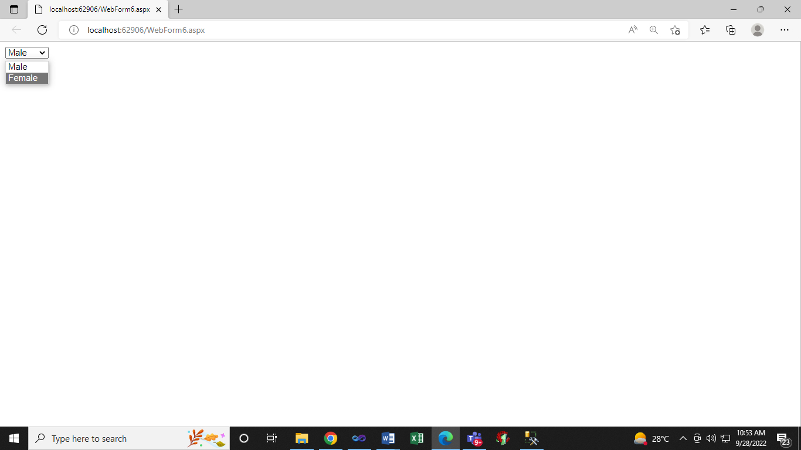

**Bind DropDownList with XML Data**

**.aspx**

<%@ Page Language="C#" AutoEventWireup="true" CodeBehind="WebForm6.aspx.cs" Inherits="WebApplication9.WebForm6" %>

<!DOCTYPE html PUBLIC "-//W3C//DTD XHTML 1.0 Transitional//EN" "http://www.w3.org/TR/xhtml1/DTD/xhtml1-transitional.dtd">

<html xmlns="http://www.w3.org/1999/xhtml">

<head runat="server">

<title></title>

</head>

<body>

<form id="form1" runat="server">

<div>

<asp:DropDownList ID="DropDownList1" runat="server"

onselectedindexchanged="DropDownList1_SelectedIndexChanged">

</asp:DropDownList>

</div>

</form>

</body>

</html>

**.cs**

using System;

using System.Collections.Generic;

using System.Linq;

using System.Web;

using System.Web.UI;

using System.Web.UI.WebControls;

using System.Data;

namespace WebApplication9

{

public partial class WebForm6 : System.Web.UI.Page

{

protected void Page_Load(object sender, EventArgs e)

{

if (!IsPostBack)

{

//Create a new DataSet

DataSet DS = new DataSet(); // namespace is System.Data

//Read the xml data from the XML file using ReadXml() method

DS.ReadXml(Server.MapPath("XMLFile1.xml"));

DropDownList1.DataTextField = "CountryName";

DropDownList1.DataValueField = "CountryId";

DropDownList1.DataSource = DS;

DropDownList1.DataBind();

ListItem li = new ListItem("Select", "-1");

// comment the above line first and run and then uncomment and run

DropDownList1.Items.Insert(0, li);

// comment the above line first and run and then uncomment and run

}

}

protected void DropDownList1_SelectedIndexChanged(object sender, EventArgs e)

{

}

}

}

**Output**

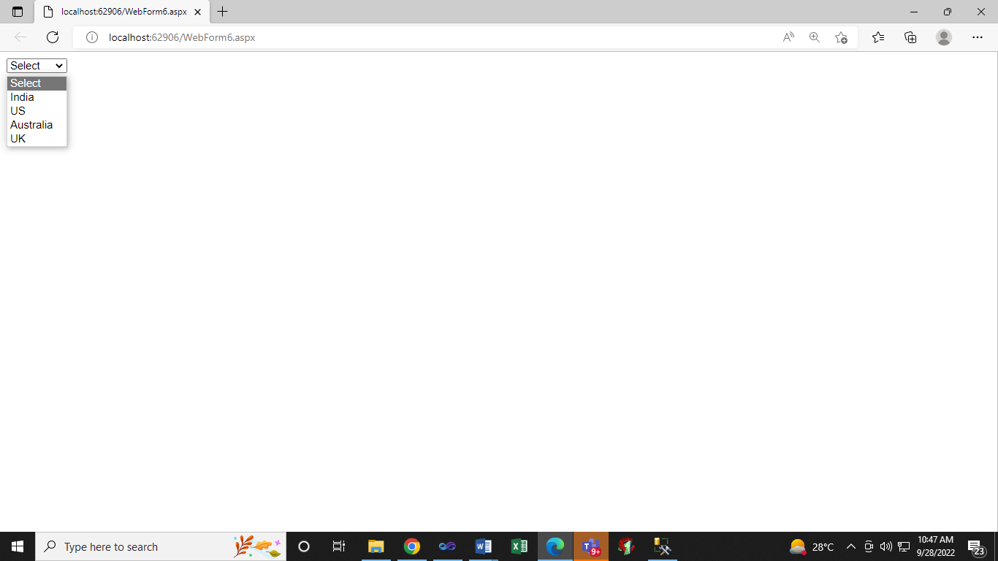

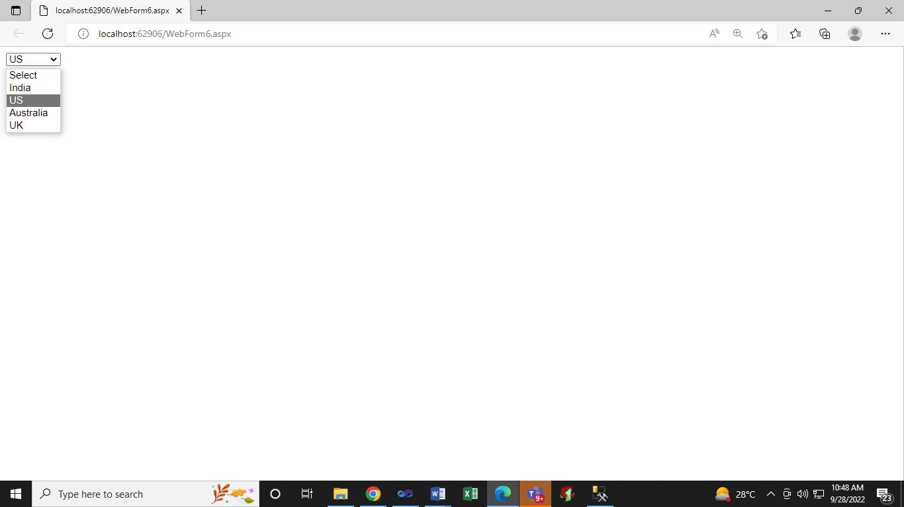

**Bind DropDownList with SQL Server Data**

**Do the following in SQL Server**

Create table tblCity  
(  
 CityId int primary key,  
 CityName nvarchar(50),  
 Country nvarchar(50)  
)  
  
Insert into tblCity values(101, 'Delhi', 'India')  
Insert into tblCity values(102, 'London', 'UK')  
Insert into tblCity values(103, 'New York', 'US')  
Insert into tblCity values(104, 'Tokyo', 'Japan')

**SET CONNECTION STRING IN web.config file just above system.web tag**

<configuration>

<connectionStrings>

<add name ="DBCS" connectionString ="Data Source = .\SQLEXPRESS;database = a; Integrated Security = SSPI" providerName ="System.Data.SqlClient" />

</connectionStrings>

<system.web>

**.aspx**

<%@ Page Language="C#" AutoEventWireup="true" CodeBehind="WebForm6.aspx.cs" Inherits="WebApplication9.WebForm6" %>

<!DOCTYPE html PUBLIC "-//W3C//DTD XHTML 1.0 Transitional//EN" "http://www.w3.org/TR/xhtml1/DTD/xhtml1-transitional.dtd">

<html xmlns="http://www.w3.org/1999/xhtml">

<head runat="server">

<title></title>

</head>

<body>

<form id="form1" runat="server">

<div>

<asp:DropDownList ID="DropDownList1" runat="server"

onselectedindexchanged="DropDownList1_SelectedIndexChanged1">

</asp:DropDownList>

</div>

</form>

</body>

</html>

**.cs**

using System;

using System.Collections.Generic;

using System.Linq;

using System.Web;

using System.Web.UI;

using System.Web.UI.WebControls;

using System.Data;

using System.Configuration;

using System.Data.SqlClient;

namespace WebApplication9

{

public partial class WebForm6 : System.Web.UI.Page

{

protected void Page_Load(object sender, EventArgs e)

{

if (!IsPostBack)

{

string CS = ConfigurationManager.ConnectionStrings["DBCS"].ConnectionString;

using (SqlConnection con = new SqlConnection(CS))

{

SqlCommand cmd = new SqlCommand("Select CityId, CityName, Country from tblCity", con);

con.Open();

SqlDataReader rdr = cmd.ExecuteReader();

DropDownList1.DataTextField = "CityName";

DropDownList1.DataValueField = "CityId";

DropDownList1.DataSource = rdr;

DropDownList1.DataBind();

}

}

}

protected void DropDownList1_SelectedIndexChanged1(object sender, EventArgs e)

{

}

}

}

